Board of Directors:
Michael Reeves President
Paul Hain
Vice-President
Emily Renzel
Secretary
Rick Carpenedo
Treasurer
Jessica Brem
Nikhilesh Dholakia
Sara Steiner

Advisors &
Committee
Members:
Dave Brigantino
Michael Brigantino
Christine Breen
Sallie Calhoun
Robert Connolly
Zooey Diggory
Dan Dungy
Katherine Foster
Mark Gibson
Jeremy Lackey
Julie Morris
Laura Naccarato
Ron Ross
Cathy Summa-Wolfe
Kerry Tobias

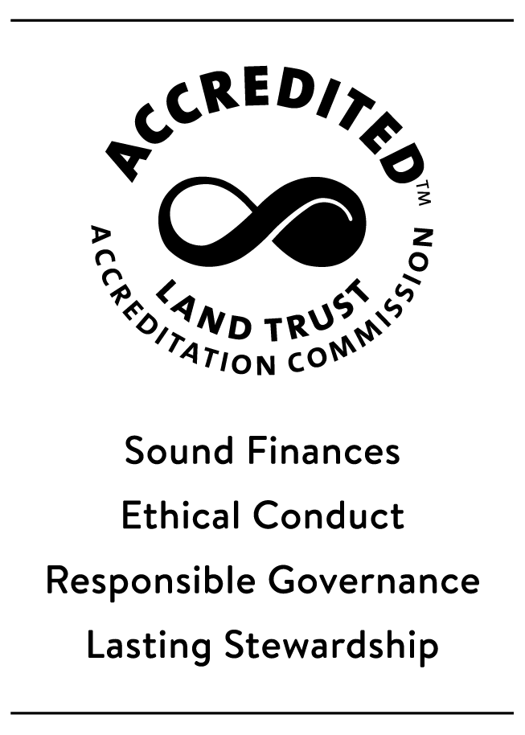

FOR IMMEDIATE RELEASE: Contact: Laura Kirschmann
August 11, 2023 Laura@sanbenitolandtrust.org 831-801-7097

San Benito Agricultural Land Trust Permanently Protects a Total of 51 Acres of Phil Foster Ranch

Phil and Katherine Foster’s Pinnacle Organically Grown in San Benito County is a leader in innovative, climate-friendly farming practices with a loyal customer following.

SAN JUAN BAUTISTA, Calif.— San Benito Agricultural Land Trust (SBALT) announces the permanent protection of 51 acres of Phil Foster Ranch, also known as Pinnacle Organically Grown, in San Benito County’s fertile San Juan Valley. The Fosters conserved the first 27 acres of their ranch in 2019. The funds for the second agricultural easement that protected the remaining 24 acres as of this July were made available through two programs. The first is the State’s Strategic Growth Council’s Sustainable Agricultural Land Conservation Program (SALC), in collaboration with the Department of Conservation. SALC is part of California Climate Investments, a statewide initiative that puts billions of Cap-and-Trade dollars to work reducing greenhouse gas emissions, strengthening the economy, and improving public health and the environment – particularly in disadvantaged communities. The second is the U.S. Department of Agriculture’s Natural Resources Conservation Service Agricultural Conservation Easement Program, which helps landowners, land trusts, and other entities protect, restore, and enhance wetlands or protect working farms and ranches through conservation easements.



“Phil and Katherine Foster, in their ongoing farming operation, represent the best of what farming can be in San Benito County. We are honored to have played a part in preserving their legacy on the land,” says Michael Reeves, President of SBALT.

Phil Foster farms 295 acres of C.C.O.F. certified organic vegetables, nuts, and fruit. They produce about 60 different crops on 295 acres across two ranches near San Juan Bautista and Hollister, California. They have a diverse range of crops, marketing at the farm on Saturdays, at farmers markets throughout the Central Coast and Bay Area, at local retail stores, and through several regional wholesalers.

The Fosters strive to maintain the Pinnacle label’s high quality by building the soil with cover crops and compost, practicing environmentally sensitive pest control, decreasing water consumption and protecting water quality, using alternatives to fossil fuels, and continually seeking to improve farming methods.

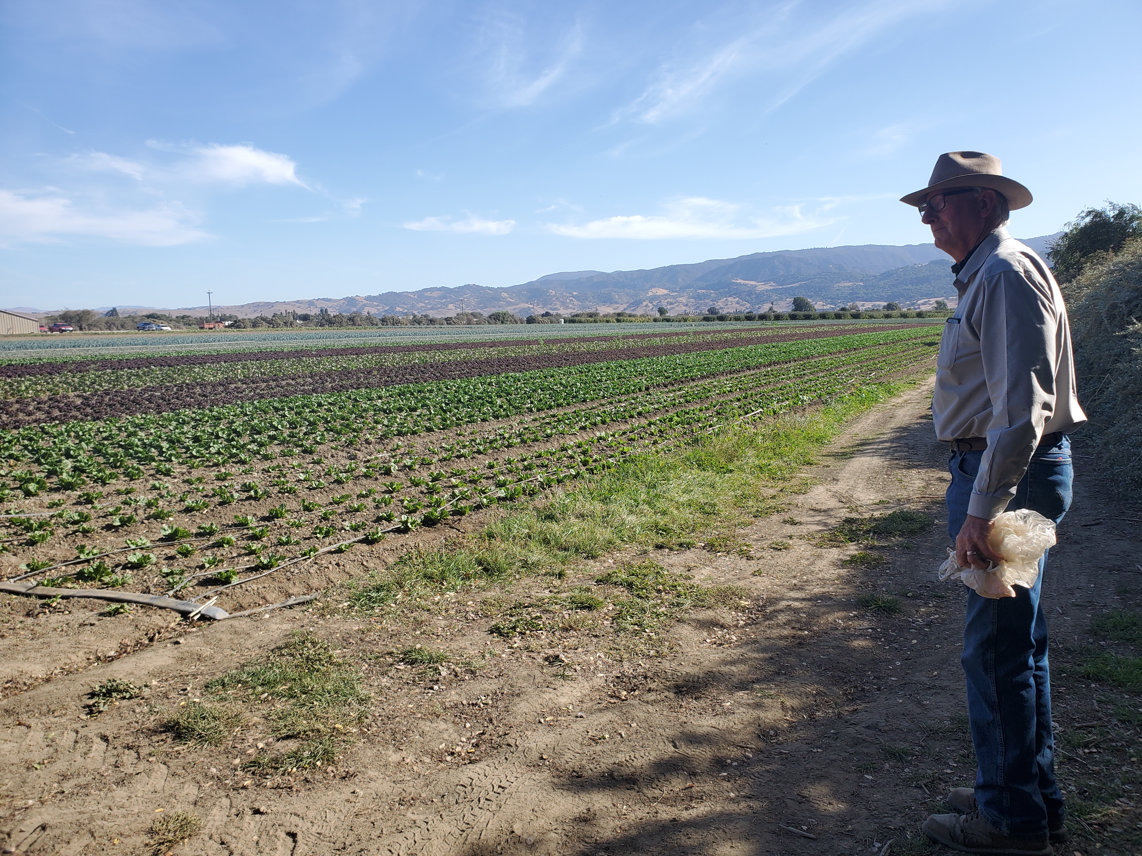Phil Foster Ranch

Owner Phil Foster says, “The funds we receive for the ag conservation easement with SBALT on part of our farmland will be beneficial to the economic viability of our farm, and will aid in future transition of our farmland to employee or younger farmer ownership with the development value of the land removed.”

This agreement ensures that the land will remain available for agricultural purposes, even as development pressures increase in the surrounding area. This milestone marks a collaborative effort between the Fosters and SBALT to ensure the longevity of agricultural traditions and support local food production. SBALT remains dedicated to promoting responsible land use practices and encouraging other landowners to explore the benefits of conservation easements.

# # #

San Benito Agricultural Land Trust is a non-profit 501(c)(3) organization headquartered in San Juan Bautista, California, and dedicated to preserving San Benito County’s working farmlands, grazing lands, and open space through voluntary partnerships with landowners, local agencies and the community. Since 1993, SBALT has protected more than 6,700 acres of productive agricultural land in San Benito County. To find out more or donate visit https://www.sanbenitolandtrust.org/.

